HOLIDAY RESORTS WEBSITE
Subject: Application of Information and Communication Technology Lab

Project Title: Holiday Resorts

Group Members:
Mirha Tayyab (2025-GA-95)
Tahreem Imran (2025-GA-91)
Hamayal Ansari (2025-GA-71)
Syed Abbas Haidar (2025-GA-98)
Abdullah Usman (2025-GA-81)

Section: B

Domain: Gaming and Animation

Instructor Name: Ms. Ramsha Khalid

Dated: 5th January 2026

Table of Contents
1.Executive Summary 3
2.Project Objectives & Scope 3
3.Site Structure & Navigation 3
• Home: 3
• Resorts: 3
• Book Now: 4
• About Us: 5
• Contact Us: 5
4.Design Choices 6
• Font: 6
• Colors: 6
• Layout: 6
• Design Style: 6
5.Assets Used 6
6.Data Source 6
Resort Name 6
6.How to Run / Publish the Site 6
7.Reflection 6

1.Executive Summary
The Holiday Resorts website is designed to provide visitors with information about different holiday resorts and allow them to book resorts easily. The website focuses on simple navigation and a clean layout so users can quickly find resort details, view options, and make bookings. This project helps users plan their holidays in a convenient and organized way.

2.Project Objectives & Scope
The main objective of this project is to create a website that helps users find and book holiday resorts. The website allows visitors to explore available resorts, learn about the services offered, and contact the management for bookings. The scope of the project includes basic informational pages and a booking option, making it suitable for general visitors looking for holiday destinations.

3.Site Structure & Navigation
The website consists of the following pages:
- Home: Introduction to the Holiday Resorts website
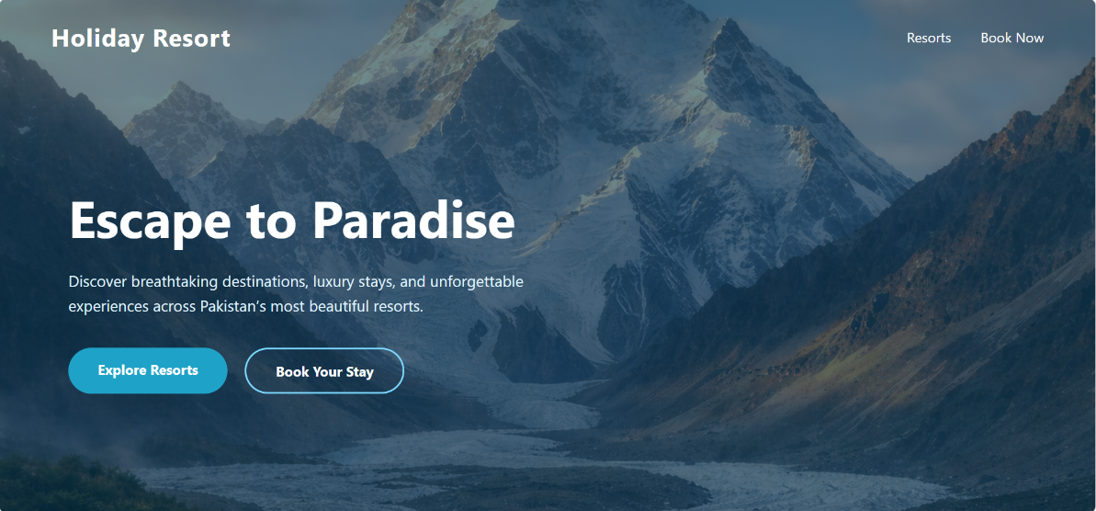

- Resorts: Displays information about available resort


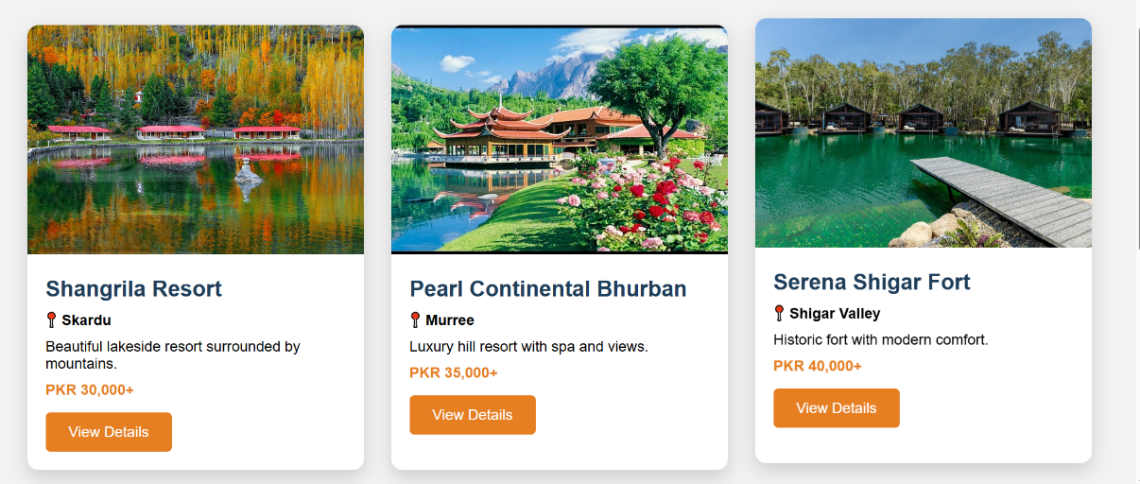

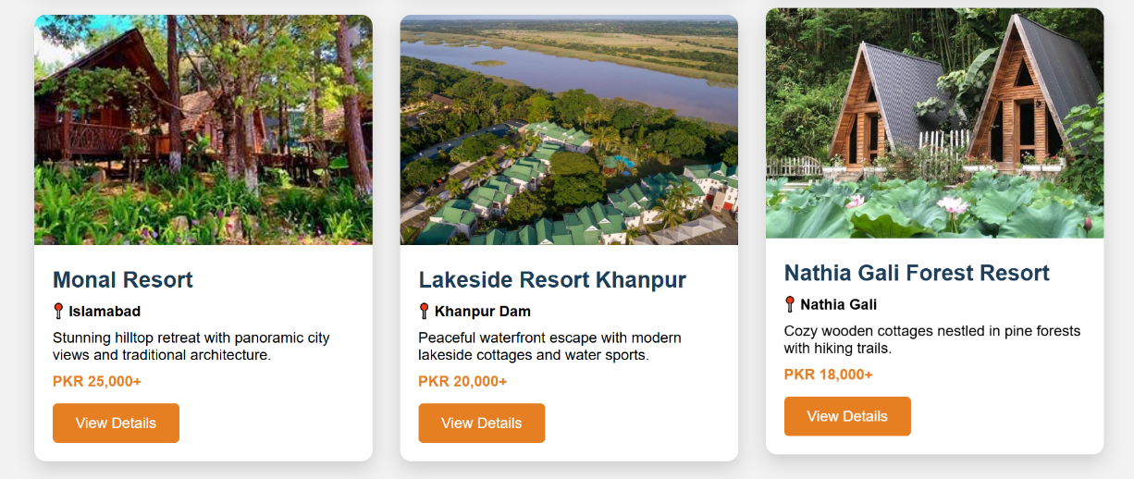

- Book Now: Allows users to book a resort


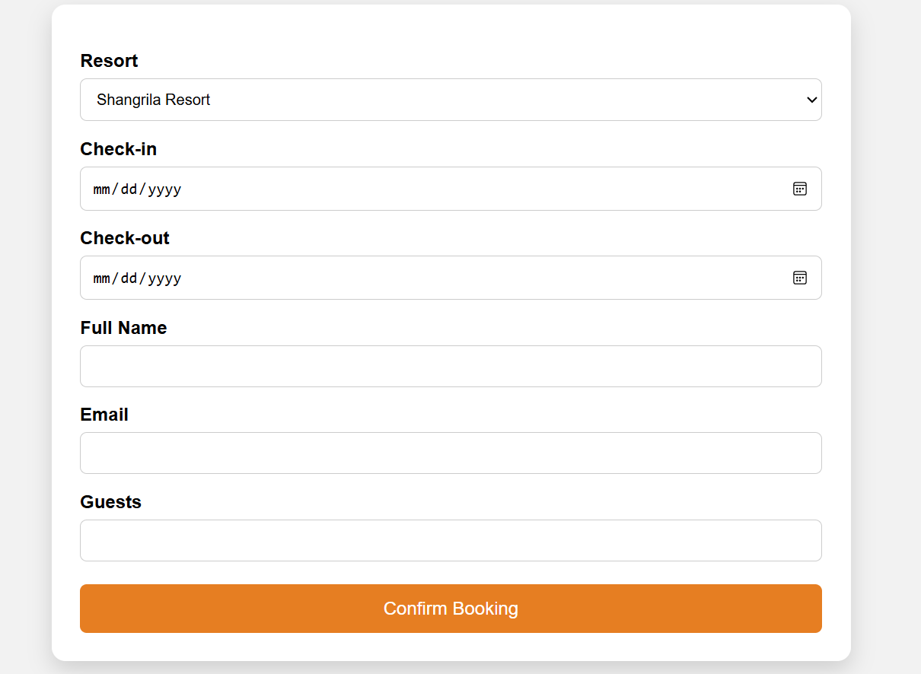

- About Us: Provides background information about the resort service


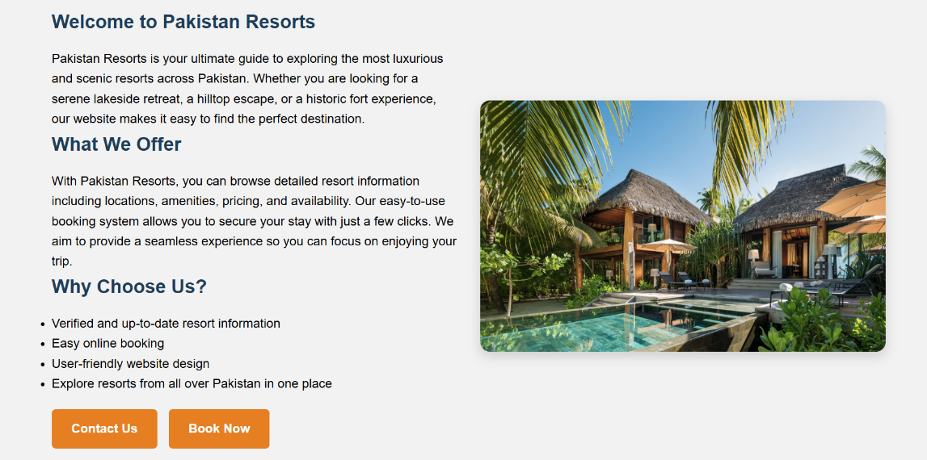

- Contact Us: Allows users to contact for inquiries or support
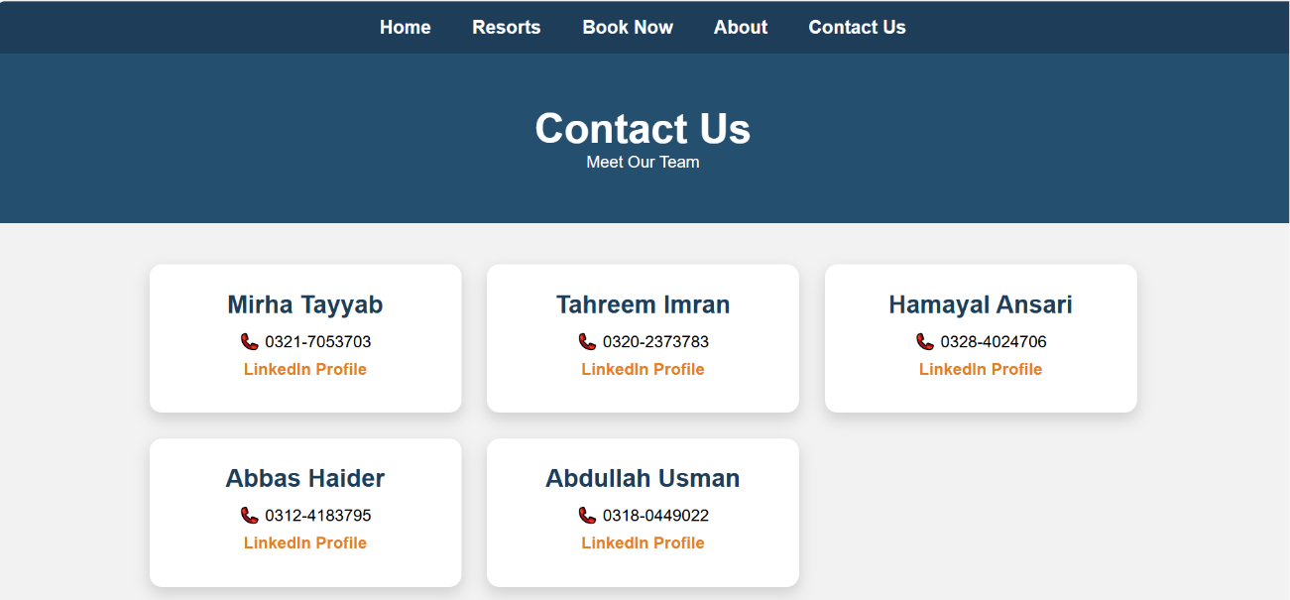

The navigation menu is clear and easy to use so users can move between pages smoothly

4.Design Choices
- Font: Times New Roman
- Colors: Simple and clean color scheme
- Layout: Simple and responsive layout using basic HTML and CSS
- Design Style: User-friendly design with clear sections and readable text
The design focuses on simplicity so users of all ages can easily understand and use the website.

5.Assets Used
The website uses images of holiday resorts for visual presentation. These images are added as sample pictures for the project. Dummy data such as resort names, prices, and booking details is used for learning purposes. No real customer data is included.

6.Data Source
Resort Name City / Area
Shangrila Resort Skardu
Pearl Continental Bhurban Murree
Serena Shigar Fort Shigar Valley
Monal Resort Islamabad
Lakeside Resort Khanpur Khanpur Dam
Nathia Gali Forest Resort Nathia Gali
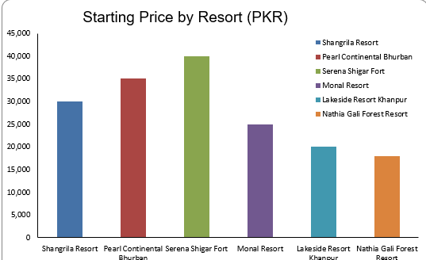

This chart and the table show example starting prices for seven holiday resorts. The prices are in Pakistani rupees.
Serena Shigar Fort has the highest starting price, around 40,000 PKR.
Pearl Continental Bhurban is also high, about 35,000 PKR.
Shangrila Resort starts near 30,000 PKR.
Monal Resort is around 25,000 PKR.
Lakeside Resort Khanpur and Nathia Gali Forest Resort are lower, around 20,000–22,000 PKR.
These numbers are sample data for this project. They help show how different resorts compare by price, which can guide a visitor choosing a place to stay.

6.How to Run / Publish the Site
The website is a basic HTML project. It can be run by opening the index.html file in any web browser.

7.Reflection
Through this project, we learned how to structure a website using HTML and CSS and how to plan website content properly. We also learned the importance of navigation and simple design. In the future, the website can be improved by adding more interactive features and completing the booking system.

